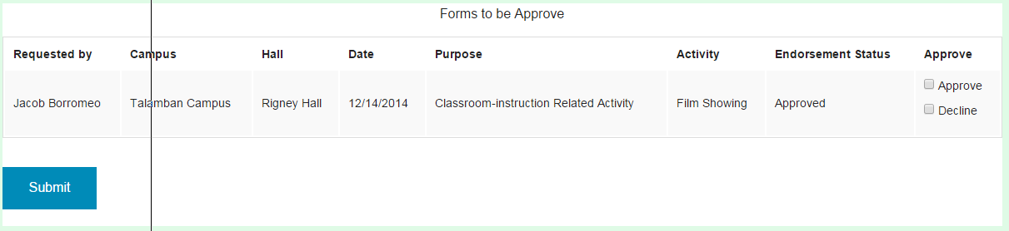

1. Requestor Column

* Description: This is where the approver views the requestor of the reservation that needs to be approved.
  + Action: Approver views the requestor’s name of the reservation.

1. Campus Column

* Description: This is where the approver views the requestor’s campus of the reservation that needs to be approved.
  + Action: Approver views the requestor’s campus of the reservation.

1. Hall Column

* Description: This is where the approver views the requestor’s hall of the reservation that needs to be approved.
  + Action: Approver views the requestor’s hall of the reservation.

1. Date Column

* Description: This is where the approver views the requestor’s date of the reservation that needs to be approved.
  + Action: Approver views the requestor’s date of the reservation.

1. Purpose Column

* Description: This is where the approver views the requestor’s purpose of the reservation that needs to be approved.
  + Action: Approver views the requestor’s purpose of the reservation.

1. Activity Column

* Description: This is where the approver views the requestor’s activity of the reservation that needs to be approved.
  + Action: Approver views the requestor’s activity of the reservation

1. Endorsement Status Column

* Description: This is where the approver views the endorsement status of requestor’s reservation.
  + Action: Approver views the endorsement status of the reservation

1. Approve Column

* Description: This is where the approver selects if he/she will approve the requestor’s reservation.
  + Action: Approver approves or disapproves the reservation.

1. Submit Button
   * Description: This is where the approver clicks when done approving the reservations.
   * Action: on click, the approval status of the reservation will change either to approve or disapprove. It will be saved in the database and a dialog box will appear to confirm.